Claims Recovery

FOR OD

1. To have a new Tab in the Claims Registration Layout – Recovery. This Recovery will show a grid that show all claim entries with Recoverable (OD) and Recoverable from Insurer (BI) = Yes.
2. Same layout as Payment Processing – under Claims Recovery Processing, user can search for Claims that have been marked “Recoverable (OD) = Yes” as well as Recoverable from Insurer (BI) - =Yes. Once User clicks on Select. This will bring user to the relevant OD Recovery Screen or BI Recovery Screen.
3. When user clicks on select, the screen will appear.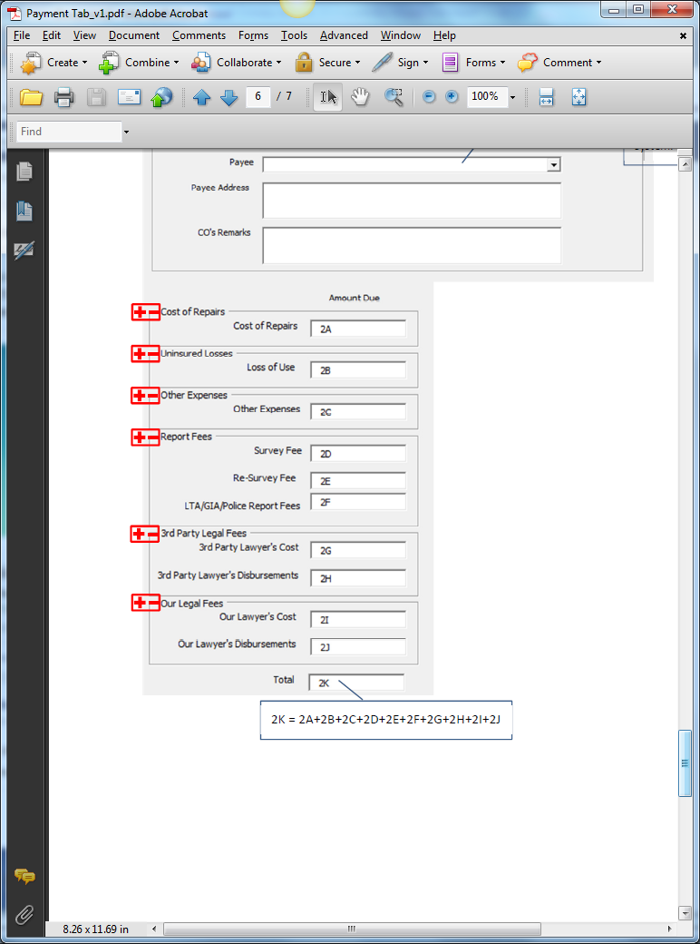

Add Approved Mandate Column. Read Only. Amount Due change to Recoverable Amount. Validation: Recoverable Amount must be greater or equal to Approved Mandate Amount.

Change to Recover From, Address to Address1, Address2, Address3, Postal Code. CO’s Remarks change to Recovery Reason

1. After User has clicked Submit, the Total Amount will be deducted from Outstanding Reserve and Mandate Amount relevant to the Claim.

For BI

1. System will tabulate and calculate all Payment Entries for TPBI Claims
2. This is activated when Recoverable From Insurer (BI) = Yes

Screen Layout:

|  |  |  |
| --- | --- | --- |
| Total TPBI Payout | << Text Field >> | This is pulled from the total values of TPBI Claims Payment |
| Deductible / Excess Limits (currently set as 15,000) | << Text Field >> | This value is pulled from CDGI’s Deductible value from own panel of Insurer or Insurance Policy (from System Admin) |
| Amount To Recover | << Text Field >> | Value = Total TPBI Payout - Deductible |
| Reason | << Text Field >> | Default to “Deductible Exceeded” |
|  |  |  |
|  |  |  |

Note: For first BI Recovery, System will take note of the Deductible / Excess Limits Value. If Total TPBI Claims Payment Payout is less than the Deductible, Recovery cannot be processed. If TPBI Recovery is processed, this value is marked and removed from subsequent TPBI Claims that are created.

Deductible / Excess Limits will not be applicable for 2nd TPBI Recovery onwards.